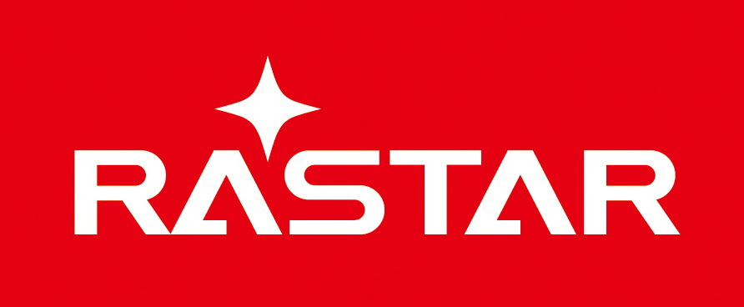 RASTAR GROUP

Add: Xinghui Industrial Park, Xiadao Road, Shanghua, Chenghai, Shantou, Guangdong, China
Tel: 0086-0754-8589 5700 Fax: 0086-0754-85897078 www.rastar.com

EC Declaration of conformity
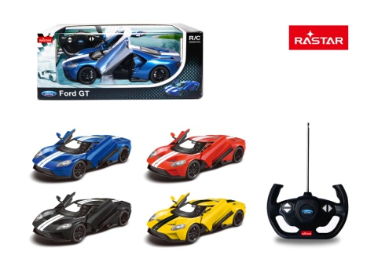

(1) Manufacturer: RASTAR GROUP
Address: Xinghui Industrial Park, Xiadao Road,
Shanghua, Chenghai, Shantou, Guangdong, China

(2) Product

No.: 78100
Description: R/C 1:14 Ford GT

(3)This declaration of conformity is issued under the sole responsibility of the manufacturer

The undersigned acting on behalf of (1) above hereby declares that:
We are fully responsible for the design and production of the product listed in (2). The products and parts included have been designed, constructed and assembled in conformity within the provisions of the following regulations and directives:

2009/48/EC Safety of toys

We also confirm that the product has been tested to the standards listed below:

Applied Standards | Documentary Evidence | Testing Organization
EN71-1:2014+A1:2018  EN71-2:2011+A1:2014  EN71-3:2013+A3:2018  EN71-3:2019 | GZHH00342149 | Intertek

For and on behalf of:
RASTAR GROUP

Division or Position: Vice Director
Date: 2020-03-05

